4.4 The Mean Value Theorem Worksheet

- Let . Determine the value of $c$ which satisfies the conclusion of the Mean Value Theorem on the interval . You must show all work and simplify your answer.

We know that is a polynomial and therefore is continuous and differentiable on any interval . Therefore by the Mean Value Theorem there is a c in such that: .

The value of c is 3.

- Prove, using the Intermediate Value Theorem and Rolle’s Theorem, that the function has exactly one real root.

Show there is a real root
We know that f is a continuous because it is a polynomial. We can see that:

Therefore by the IVT there exists a number c in the interval such that .
Therefore we have shown that has at least one real root.

Show there cannot be two real roots
Assume that there are two real roots, say (so we are calling roots).
Since f is a polynomial, we know that is continuous on the interval and differentiable on the interval , regardless of what the values of are. Therefore, we have satisfied the conditions for Rolle’s Theorem so we can then say, there is a number d in such that .
We note that: .

However, when we look to find when we can see that this is not possible, since the discriminate . This is a Contradiction!

Therefore, our initial assumption must be false. There cannot be two real roots.
So we have shown that the function has exactly one real root.

- Verify that , satisfies the hypothesis of the Mean Value Theorem. Then find all c that satisfy the conclusion of the Mean Value Theorem.

is everywhere continuous and everywhere differentiable so it is clearly continuous on and differentiable on . So by the MVT there is a c in the interval such that .
So we want to find all values c such that . We observe that . So when does ?

The value of c is .

- Verify that the hypothesis of Rolle’s Theorem are satisfied for the function on the interval , and find all values of c in that interval that satisfy the conclusion of the theorem.

Hypotheses
- f is continuous on because f is a radical minus a polynomial.
- f is differentiable on because only non-differentiable at .

By Rolle’s Theorem there is at least one point c in such that .

- Let . Show that but there is no number c in the interval such that . Why does this not contradict Rolle’s Theorem?

Notice that . So is undefined when .
So f is not differentiable on the interval $.$

- Use Rolle’s Theorem to prove that the function has exactly one real root.
Show there is a real root
We know that f is a continuous because it is a polynomial plus a trigonometric function. We see that:

Therefore by the IVT there exists a number c in the interval such that.
Therefore we have shown that has at least one real root.

Show there cannot be two real roots
Assume that there are two real roots, say (so we are calling roots).
Since f is a polynomial plus a trigonometric function, we know that is continuous on the interval and differentiable on the interval , regardless of what the values of are. Therefore, we have satisfied the conditions for Rolle’s Theorem so we can then say, there is a number d in such that .
We note that: .

However, when we look to find when we can see that this is not possible.
Contradiction!

Therefore, our initial assumption must be false. There cannot be two real roots.
So we have shown that the function has exactly one real root.

- Use Rolle’s Theorem to prove that the function has at most two real roots.

Show there is a real root
We know that f is a continuous because it is a polynomial. We see that:

Therefore by the IVT there exists a number c in the interval such that.
Therefore we have shown that has at least one real root.

Show there cannot be two real roots
Assume that there are three real roots, say (so we are calling roots). Suppose for the sake of argument that . Since f is a polynomial, we know that is continuous on the intervals and . We also know that f is differentiable on the intervals and . Therefore, we have satisfied the conditions for Rolle’s Theorem (twice) so we can then say, there is a number in and a number in such that .
We note that: .

However, when we look to find when we can see that this is only one possible value for which .
Contradiction!

Therefore, our initial assumption must be false. There cannot be three real roots.
So we have shown that the function has at most two real roots.

- You are driving on a straight highway with a speed limit is 55 mi/h. At 8:05am a police car clocks your velocity at 50 mi/h and at 8:10am a second police car posted 5 miles down the road clocks your velocity at 55 mi/h. Explain why the police have the right to charge you with a speeding violation?

You traveled 5 miles and the time elapsed in
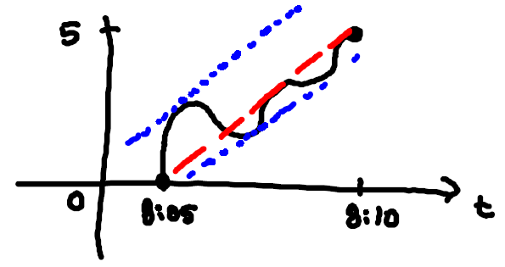
So, .
Therefore, the Mean Value Theorem guarantees the police that your instantaneous velocity was 60mph at least once over the 5 mile section of the highway.

